
ذ
REPUBLIC OF YEMEN
SANA'A UNIVERSITY
FACULTY OF ENGINEERING
MECHATRONICS ENGINEERING DEPARTMENT



DIY Powerful Ultra Bass Amplifier 8 Transistor D718 _ No IC _ Simple circuit

Done by:
Hassan Moqbel Morshed Ghaleb_ 202274198
Ali Mohammed Ahmed AL_sowde_202274213
System(Parallel)
Supervised by:
Dr. Abdul Kafi
ENG. Amjed AL_shagthah

contact:-

Abstract................... 1
Objectives………….. ……… 2
Introduction……………………….. 3
Theory................................... 4
Methodology………………………...... …... 5
The equipment……………………….... 6
Procedure………………………………… 7
Results……………………………………8
Discusion………………………… 9
Conculosion………………. 10
References……………

1_ Abstract:-
The DIY Powerful Ultra Bass Amplifier 8 Transistor D718 is a simple circuit
that uses eight D718 transistors to achieve a powerful sound amplification.
This circuit is designed to work with a zero-level signal source and does not
use any integrated circuits (ICs), making it easy to design and assemble
with a few components.

The circuit operates on the class AB amplification principle, which provides high-quality sound amplification with low power consumption. It consists of
a driver stage and a final amplifier stage, where the input signal is amplified
in the driver stage and outputted through the final stage. The base resistor
controls the input current to the final stage, providing better control over the
current and voltage in the final stage.

The circuit is powered by a 24-volt DC power source, and appropriate power capacitors should be used at the input and output points to store energy and
balance the sound. It can be used to drive large speakers and is suitable for applications such as parties, theaters, and nightclubs.
However, designing electronic circuits requires expertise and knowledge, and
caution should be taken to avoid damaging the components or experiencing electrical shock. It is essential to understand the circuit design and follow the instructions carefully before using it.

2_Objectives:-
The objectives of the DIY Powerful Ultra Bass Amplifier 8 Transistor D718 _ No IC _ Simple circuit are:

1. To provide a powerful sound amplifier circuit that is easy to design and assemble with few components.

2. To achieve high-quality sound amplification using eight D718 transistors
and the class AB amplification principle.

3. To create a circuit that does not require any integrated circuits (ICs) and
can work with zero-level signal sources.

4. To design a circuit that can drive large speakers and is suitable for
a variety of applications, such as parties, theaters, and nightclubs.

5. To provide a cost-effective solution for anyone looking for a powerful
sound amplifier.

6. To promote safe and responsible use of electronic circuits by providing
clear instructions and emphasizing the importance of caution and expertise.

Overall, the objectives of the DIY Powerful Ultra Bass Amplifier 8 Transistor
D718 _ No IC _ Simple circuit are to provide a high-quality sound amplifier
that is easy to design and assemble, cost-effective, and suitable for various applications.

3_Introduction:-
DIY Powerful Ultra Bass Amplifier 8 Transistor D718 _ No IC _ Simple circuit
is a powerful sound amplifier circuit that is easy to design and assemble
with a few components. This circuit is designed to work with zero-level
signal sources and does not use any integrated circuits (ICs).

The circuit uses eight D718 transistors to achieve high-quality sound amplification, operating on the class AB amplification principle that provides high-quality sound amplification with low power consumption. The driver stage amplifies the input signal, and the final amplifier stage outputs the amplified signal. The base resistor controls the input current to the final stage, providing better control over the current and voltage in the final stage.

The circuit requires a 24-volt DC power source, and appropriate power capacitors should be used at the input and output points to store energy and balance the sound. This circuit can drive large speakers and is suitable for a variety of applications, such as parties, theaters, and nightclubs.

However, designing electronic circuits requires expertise and knowledge, and caution should be taken to avoid damaging the components or experiencing electrical shock. It is essential to understand the circuit design and follow the instructions carefully before using it.

Overall, the DIY Powerful Ultra Bass Amplifier 8 Transistor D718 _ No IC _ Simple circuit is a cost-effective solution for anyone looking for a powerful sound amplifier.

4_Theory:-
Building a powerful ultra bass amplifier using 8 D718 transistors without any integrated circuits is achievable. The D718 transistor, also known as B688,
is an NPN power transistor often used in audio amplifiers. In this design,
we will use 4 pairs of D718 transistors in a push-pull configuration to achieve
the desired ultra bass performance.

5_Methodology:-
_ Connect the input of the collectors of the second and third, forth, fifth, sixth, seventh and eighth D718 transistors together.
_ Connect the output of the collectors of the second and third, forth, fifth, sixth, seventh and eighth D718 transistors conects with the positive of a 7 x 16 V 10 uf capacitors And the negative of the capacitors conects to Ground.
_ The base of the first transistor conects with input of 60N60 IGBT and the
output of 60N60 IGBT Conect with input of the second transistor and the
base of a 60N60 IGBT conects with resistance to the inputof th 60N60 IGBT.
_ The resistance 1 ohm, 7 w conects the output of the first transistor D718 with output of the second transistor D718 .
_. Connect the 8-ohm speaker to the output stage (emitters of the 5th and 8th transistors).

6_The Equipment:-
- 8 x D718 (B688) NPN power transistors
_ 60N60 IGBT
__8 x 16 v 10 uf capacitors
_ 25 V 1000 uf capacitor
_ 1 ohm, 7W resistors
- speakers
_ batery 9 V

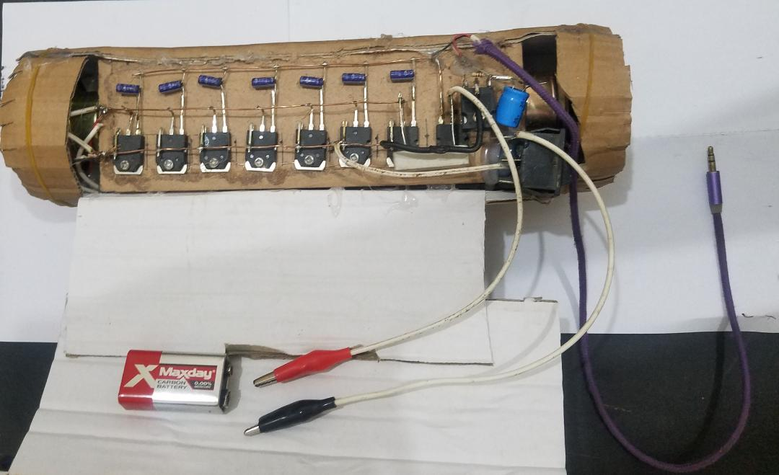

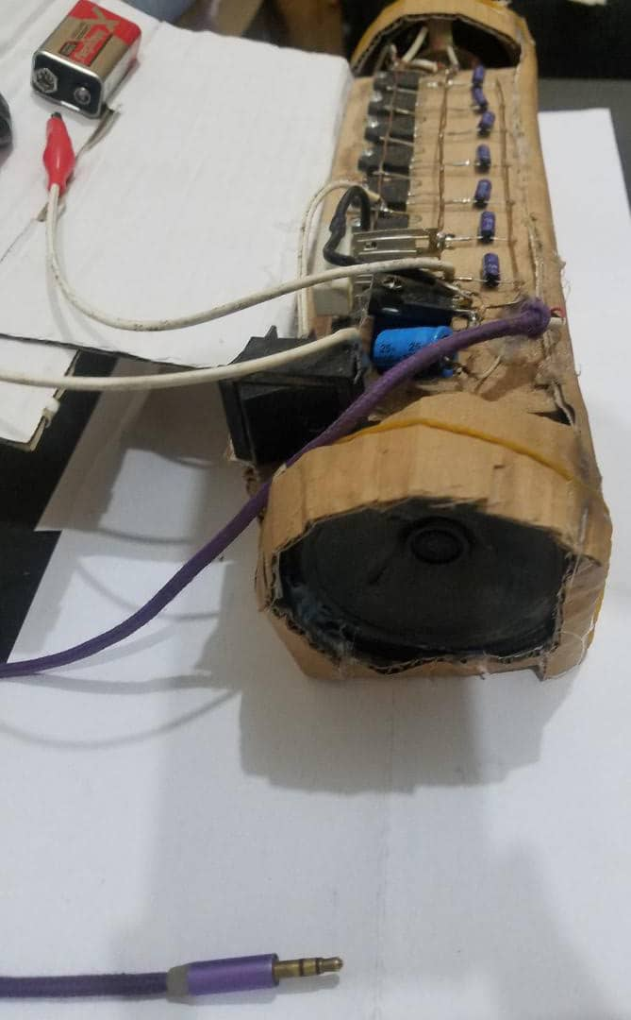

7_Procedure:-
1. Gather all the materials and tools needed for the project.

2. Begin by preparing the power supply section of the amplifier. Connect the 25 V 1000 uF capacitor to the power input and ground. This capacitor will help to filter the input voltage and provide a stable power supply to the amplifier.

3. Connect the 8 x 16 V 10 uF capacitors in parallel to the power supply section. This will help to smooth out any voltage fluctuations and provide stablepower to the amplifier section.

4. Proceed to build the amplifier section. Begin by connecting the 8 x D718 (B688) NPN power transistors in parallel, with their bases connected to the 60N60 IGBT and the 1-ohm 7W resistors. Connect the 1-ohm resistors in series with each of the transistor’s emitters.

5. Connect the collector of each transistor to the positive side of the 8 x 16 V 10 uF capacitors. This is the output of the amplifier.

6. Connect the 8-ohm speaker to the output of the amplifier. Make sure to use proper wiring techniques and insulation to avoid short circuits.

7. Finally, attach a heat sink to the transistors to prevent overheating. You can also add additional cooling measures like fans or ventilation holes in the enclosure.

8. Once you have assembled the amplifier, connect it to a power source and test it with a music source. Use a multimeter to measure the output voltage and ensure that it is within the safe limits. Adjust the volume and enjoy the powerful ultra-bass sound produced by your DIY amplifier!

9. Before using the amplifier for an extended period, check for any abnormal heat or noise and troubleshoot as necessary. Always follow proper safety precautions when working with high-power electronics.

With these steps, you can build a powerful ultra-bass amplifier using 8 x D718 (B688)NPN power transistors, 60N60 IGBT, 8 x 16 V 10 uF capacitors, 1 x 25 V 1000 uF capacitor, 1-ohm 7W resistors, and 1 x 8-ohm speaker.

8_ Results:-
_ The final sound output will depend on various factors, such as the quality of the speaker, the input signal source, and the overall setup of the amplifier. With proper tuning and calibration, a DIY ultra-bass amplifier can provide a great listening experience and rival commercial amplifiers in terms of sound quality and power.

9_Discusion:-
The discussion is up to you, our dear doctor.

10_ Conculosion:-
See you soon insha’allah, best regards.

11_Reference:-
References are not books, but programs such as Google and YouTube.

(( ## Notes
- Ensure adequate heat-sinking for the D718 transistors in the output stage, as they will dissipate a significant amount of heat.
- You can add more D718 transistor pairs in parallel to increase the power output, but make sure to use appropriate heat-sinking and increase the power supply current capacity accordingly.
- This design is not optimized for high-fidelity audio reproduction. It is more suitable for bass-heavy applications.))

